EXPERIMENT NO. 4
DESIGN AND IMPLEMENTATION OF EDGE–CLOUD SYNCHRONIZATION USING LOCAL MQTT BRIDGE (GOOGLE COLAB VERSION)
Aim
To simulate Edge–Cloud synchronization by collecting IoT sensor data at an edge device, synchronizing it to the cloud, and performing real-time analytics using Python in Google Colab.
Software required
- Google Colab
- Python 3
- pandas
- numpy
- matplotlab
Procedure:
- Open Google Colab and create a new notebook.
- Import the required Python libraries such as Pandas, NumPy, Matplotlib, Random, Time, and IPython Display.
- Initialize separate storage for the edge device and the cloud.
- Generate water level sensor readings randomly to simulate data from a smart water tank.
- Store the generated water level data in the edge device memory.
- Synchronize the collected data from the edge device to the simulated cloud storage.
- Calculate statistical measures such as Mean, Moving Average, and Standard Deviation using the synchronized cloud data.
- Compare the current water level with the predefined threshold to detect Low Water Level conditions.
- Display the edge device information, cloud analytics, and water level status.
- Visualize the synchronized water level data using a line graph with a critical water level threshold.
- Save the synchronized cloud data as a CSV file for future analysis.
- Observe the output and conclude the experiment.

Theory:
- Edge Computing processes data close to the IoT device, reducing latency.
- Cloud Computing stores and analyzes synchronized data for long-term monitoring.
Data Flow:
IoT Device
↓
Edge Device
↓
MQTT Bridge (Simulation)
↓
Cloud Storage
↓
Dashboard
Algorithm:
- Start Program.
- Generate Water Tank Level.
- Store data in Edge Memory.
- Synchronize data to Cloud.
- Calculate Mean.
- Calculate Moving Average.
- Calculate Standard Deviation.
- Detect Low Water Level.
- Display Graph.
- Save CSV.
Google colab code:
import random
import pandas as pd
import numpy as np
import matplotlib.pyplot as plt
from IPython.display import clear_output
import time
edge_storage = []
cloud_storage = []
time_data = []
for i in range(1,51):
water_level = random.randint(10,100)
# Edge Storage
edge_storage.append(water_level)
# Synchronize to Cloud
cloud_storage.append(water_level)
time_data.append(i)
mean = np.mean(cloud_storage)
std = np.std(cloud_storage)
if len(cloud_storage)>=5:
moving=np.mean(cloud_storage[-5:])
else:
moving=mean
if water_level<20:
status="LOW WATER LEVEL"
else:
status="NORMAL"
clear_output(wait=True)
print("=========== EDGE DEVICE ===========")
print("Current Water Level :",water_level,"%")
print("Stored at Edge :",len(edge_storage))
print()
print("=========== CLOUD ===========")
print("Cloud Records :",len(cloud_storage))
print("Mean :",round(mean,2))

print("Moving Average :",round(moving,2))
print("Standard Deviation :",round(std,2))
print("Status :",status)
plt.figure(figsize=(10,4))
plt.plot(time_data,cloud_storage,marker='o')
plt.axhline(20,color='red',linestyle='--',label='Critical Level')
plt.xlabel("Sample")
plt.ylabel("Water Level (%)")
plt.title("Edge–Cloud Synchronization")
plt.legend()
plt.grid(True)
plt.show()
time.sleep(0.5)
df=pd.DataFrame({
"Sample":time_data,
"Water Level":cloud_storage
})
df.to_csv("cloud_water_data.csv",index=False)
print("Experiment Completed Successfully")
OUTPUT
=========== EDGE DEVICE ===========
Current Water Level : 18 %
Stored at Edge : 32
=========== CLOUD ===========
Cloud Records : 32
Mean : 54.81
Moving Average : 29.20
Standard Deviation : 21.65
Status : LOW WATER LEVEL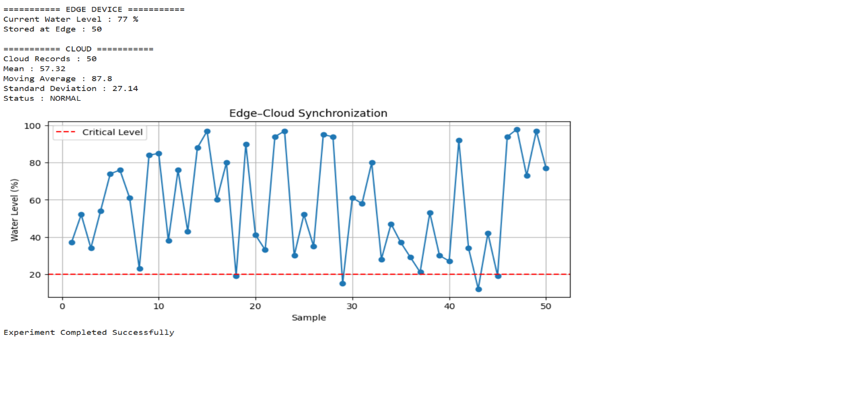
Result :
The edge device successfully collected water level data and synchronized it with the cloud. The cloud performed stream analytics using Mean, Moving Average, and Standard Deviation, detected low water level conditions, and stored the synchronized data for future analysis.

